GROUP E

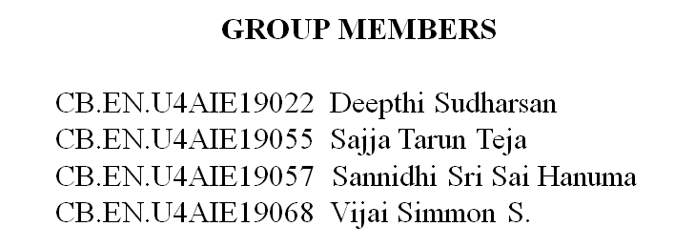

Work Distribution (As of now):

Deepthi, Vijai and Hanuma - the hardware implementation in Raspberry Pi

Deepthi and Vijai - the hardware implementation in Pluto

Tarun with the help of Hanuma and the rest of us based on the help required - research and find contents and concepts related to the topic and compile them all together for the report and PPT . And also if any other coding part or something comes up during the process.

The Work distribution may be revised after the class discussion as we have certain doubts regarding what all is to be done.

Concepts

## Modulation

Any information signal can’t be directly transmitted without alteration. It has to be modified. For electromagnetic transmission, the information signal must be converted into an electric signal prior to transmission. This conversion is accomplished by a transducer. After conversion it is used to modulate a carrier signal.

## AM Transmitter

For Amplitude modulation the transmitter uses the information signal, Vm(t) to vary the amplitude of the carrier, Vco to produce a modulated signal, VAM(t). The mathematic form of the given signals are:

* Information: Vm(t)
* Carrier: Vc(t) = Vco sin (2 pfc t + f)
* AM: VAM(t) = { Vco + Vm(t) }sin (2 pfc t + f)

Transmitters that transmits AM signals are called as AM transmitters.

These transmitters are used in medium wave (MW), short wave (SW) frequency bands of AM broadcast. SW band has the frequencies ranging from 3MHz to 30 MHz. MW band has the frequencies ranging from 550KHz to 1650 KHz. The two types of AM transmitters are used based on their transmitting powers high level and low level.

With low-level modulation, the modulation takes place prior to the output element of the final stage of transmitter. In high-level modulators, the modulation takes place in the final element of the final stage of transmitter Low-level versus high-level modulation.

With low-level modulation, less modulating signal power is required to achieve a high percentage of modulation. For high-level modulation, the carrier signal is at its maximum amplitude at the final element, therefore much higher amplitude modulating signal is required to achieve high percent modulation. However, low-level modulation is not suitable for high-power applications when all the amplifiers that follow the modulator stage must be linear

## AM Receiver

The AM receiver takes the amplitude modulated wave as an input and produces the original audio signal as an output. Selectivity is the ability of selecting a particular signal, while rejecting the others. Sensitivity is the capacity of detecting RF signal and demodulating it, while at the lowest power level.